referral guidance
for referrals to the KeepingWell NCL Hub Complex Trauma Pathway
Contents
Introduction 1
How to refer 1
Who we see 1
What we offer 1
Further resources 2

Introduction
KeepingWell NCL is now accepting referrals of health & care staff to be seen through our Complex Trauma Pathway.
This is a fast-track treatment pathway delivered through the Traumatic Stress Clinic at Camden & Islington NSH Foundation Trust. The pathway provides rapid access to evidence-based psychological treatment for health and social care staff with complex post-traumatic stress disorder (PTSD) due to multiple and prolonged traumatic events in the context of the Covid-19 pandemic.

How to refer
We accept referrals from any NCL colleagues, wellbeing leads, or HR directors. We can also accept self-referrals from all health & care staff in North Central London.
To refer a health or care staff member to this service, please email keepingwellncl@tavi-port.nhs.uk, marking your email as ‘Referral – Complex Trauma’.
Please note that from January 2022 there also will be a live referral form available to all referrers via our website.
Should you require any advice or guidance before referring a health or care staff member to this service, the KeepingWell Hub Team are able to offer a brief consultation via the email above.

Who we see

Health and social care staff resident or working in the boroughs of Camden, Islington, Barnet, Enfield or Haringey

PTSD to multiple or prolonged traumatic events in the context of the Covid-19 pandemic
Including presentations where the pandemic may have re-triggered or exacerbated past trauma memories and PTSD symptoms

Cases where PTSD or complex traumatic grief reactions are the primary diagnosis

Cases where presentation is too complex for treatment within primary care services diagnosis

Clients able to identify clear traumatic memories which they want to process and wish to engage with structured, trauma-focused and reliving-oriented treatment.

Clients sufficiently stable to engage in trauma processing
I.e. no active psychotic symptoms, alcohol, drug or medication abuse or dependence, severe depression or suicidality, or any other severe current risk to self or others

You may also wish to consult the internal KeepingWell NCL Decision Tree and pathway for PTSD cases, below:

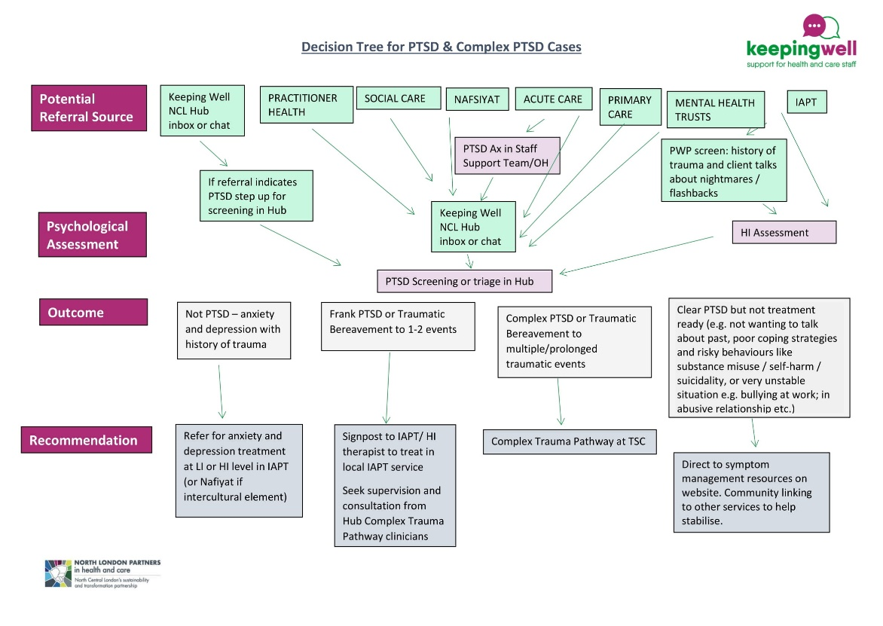
Figure 1 KeepingWell NCL Decision Tree for PTSD Cases

What we offer
The Complex. Trauma Pathway can offer:
- Assessment and evidence-based psychological treatment for complex PTSD, including cognitive therapy for PTSD (CT-PTSD) and EMDR
- Assessment and treatment of complex traumatic bereavement
- Link with IAPT services across NCL and the Keeping Well NCL Hub to support a stepped care model for PTSD care
This service is free and completely confidential.

Further resources
The KeepingWell NCL website has lots of information, resources and useful tools for understanding and coping with traumatic stress.
Please visit www.keepingwellncl.nhs.uk and search ‘trauma’.

Any questions?
Please don’t hesitate to get in touch with the KeepingWell NCL Hub by emailing us at keepingwellncl@tavi-port.nhs.uk.

